
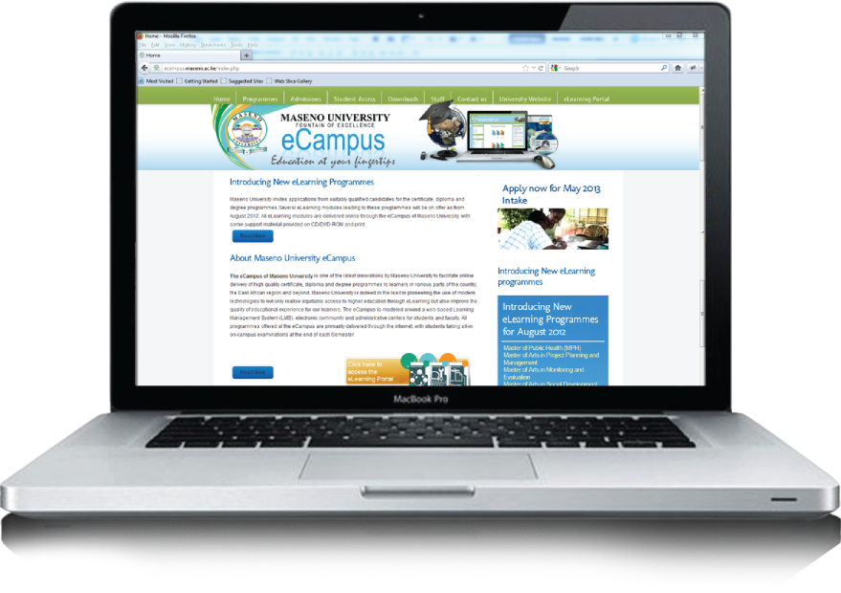

TOPIC 1: <Topic Name>
COURSE CODE: <COURSE TITLE>

P.O. Box 3275 - 40100, KISUMU | Tel: 057-2021013 | email: ecampus.@maseno.ac.ke |
http://ecampus.maseno.ac.ke

table of contents
1. Topic overview 2
1. Introduction 2
2. Objectives 3
3. Learning Activities 3
4. Assignment 3
2. Main Content 4
Subtopic 1 4
Subtopic 2 4
Subtopic 3 4
Subtopic 4 4
3. Wrap Up 4

Topic overview

Introduction
In this topic, we will learn basic concepts of Multimedia. We will discuss the various benefits and applications of multimedia.

Objectives
By the end of this topic, you should be able to:
- Define
- List
- Identify
- Describe
(Refer to blooms taxonomy to guide in stating objectives) <- delete this text when done

Learning Activities
- Resources and materials and how to use them
- Discussion activities
- Exercises ( project based preffered)

Assignment
Add your weekly Assignment here ( optional)

Main Content

Add notes

Subtopic 1
Add notes

Subtopic 2

Add notes

Subtopic 3

Add notes

Subtopic 4

Add notes

Wrap Up

Add your summary

