


Course Development Framework
Doc No : <to be added here>

P.O. Box 3275 - 40100, KISUMU | Tel: 057-2021013 | email: ecampus.@maseno.ac.ke |
http://ecampus.maseno.ac.ke

table of ctontents
1. Introduction 4
2. Structural Components of an eLearning Course 4
a) Course Information 4
b) Topic elements 5
c) Assessment Activities 7
3. Course Content & Packaging 8
3.1. Structure and navigation 8
3.2. Content formats 9
3.3. File size 9
3.4. Voice over PowerPoint as Course Content 10
3.5. Proposed Course Structure on LMS 10
a) Course information 10
b) Topic section 10
c) Discussion Forum 12
d) Assignment 12
Appendix 13
Appendix 1: Course Outline 13
Appendix 1: Lecture Notes 13
Appendix 1: Sample course information 13
Appendix 1: Sample topic in a Module 13

INTRODUCTION

STRUCTURAL COMPONENTS OF AN ELEARNING COURSE

The following are basic structural components in courses and resources developed at the eCampus of Maseno University. While some modification is expected in the course of developing content, course developers are encouraged to use the elements listed below in developing online courses.

Course Information

The following are required elements for the Course Information area:
- Course Banner
- Course Code; Course title
- Prerequisites (If any)
- Lecturer Contact (name, telephone, e-mail)
- Lecturer provides brief biographical information (photo/video) – in his profile
- Welcome message (text & video)
- Course description* (expected proficiencies required for course)
- Course Aims
- Course Objectives
- Learning Outcomes
- Course Outline and Schedule (course calendar and/or pacing expectations)
    - Programme Name
    - Course Code & Name
    - Course Objectives
    - Expected Learning Outcomes
    - Lecture Schedule (Week, topic, hours, content)
    - Course Evaluation (Assessment, grading, Passmark)
    - Mode of delivery (Description of instructional methods)
    - Instructional materials and equipment (technical requirements: software, plugins)
    - Lecturer Contact Information (Name, Tel, and E-mail)
- Course Delivery (response time on opening topics, response time on answering questions)
- Copyright Information
- Technology (information on support services)
- General Forums
  - News Forum
  - Social Forum
  - Question & Answer Forum
  - Course Chat (Regularly scheduled office hours to chat with learners)
- Getting Started folder (instructions on how to begin)

Topic elements

The following elements will be developed in each of the 10 topics in a module. All these elements should be made available before the topic is made accessible to students.

- Title
- Descriptive title of the topic corresponding to the Course Outline.
- Introduction
- A short narrative or description of the topic
- Summary of content to be covered
- Objectives
Objectives that will be met by the learner upon completion of the topic, stated in a measurable terms
- Learning Activities
Core Tasks
- Initial Activity : Discussion thread
- an activity that assists in learning and retaining the knowledge taught in the topic
- used to introduce the key concepts in the module
- serves as a way for learners to determine their prior knowledge and begin to engage in the work
- provides motivation and focuses their attention
- Course Material
- Lecture notes(Mandatory)
- External course materials
- Format for sharing content with the learners may be presented in html text, PDF or PPT formats or in multimedia (video, audio, animation, voice over)
- Real-time interaction
- Messaging
- Chat
- Video conferencing
- Assignments / application
- Must model good practices
- should be practical in nature and link theory to practice
- Learners must be told to whom, under what conditions, when and in what manner the assignments should be completed and submitted.
- Activities can ask learners to write and post the answers online or upload a document. Lecturers will provide feedback upon marking this assignments.
- Self-assessment exercises
- Provide a method that learners can use to assess their understanding of the material presented
- Include scaffold inquiry points that suggest things that a response should include

- Discussion forum
- on this forum, learners will carry out discussions, often guided by questions that encourage higher order thinking on the content of the module
- tips to guide the reflections should be placed in the activity section as hints
Discussion topic Summary
- should relate to the module objectives
- not simply be the re-wording of these
- should be posted as a thread at the end of every week (feedback to learners)
- Reading Materials
- Additional readings and resources in other courses and resources in this project that extend or support the learner’s understanding of the content of this topic.

Assessment Activities

The Course Developer shall a detailed description of:
- The final course assignment/project.
- Proposed topic assignments/activities/discussions and how they relate to the final course assignment/project.
- The rubrics that will be developed to assess each graded assignment/ activity/ discussion.
- The breakdown of grades based on the proposed assignments/activities/graded discussions.

An eLearning Module shall comprise seven assignments. This include two (2) Teacher Marked Assignments ( TMAs), four (4) Computer Marked Assignments (CMAs) and one (1) Peer Assessments (PAs). TMAs should be designed to call for learners to submit an assignment between 1500 - 2000 words. They should be typed using 12 pt. font and 1.5 line spacing with a 1-inch (2.5 cm) margin all around for Lecturer comments.

Distribution of Assignments:

ASSESSMENT ACTIVITY | RECOMMENDED TYPE OF ASSIGNMENTS | TOTAL MARKS (%)  UNDERGRADUATE | TOTAL MARKS (%)  POSTGRADUATE
Topic 1 - Assignment 1 | Computer Marked Assignments (CMAs) | 30% | 40%
Topic 2 - Assignment 2: | Computer Marked Assignments (CMAs) | 30% | 40%
Topic 3 - Assignment 3: | Teacher Marked Assignments ( TMAs) | 30% | 40%
Topic 4 - No Assignment: | None | 30% | 40%
Topic 5 - Assignment 4: | Computer Marked Assignments (CMAs) | 30% | 40%
Topic 6 - Assignment 5: | Teacher Marked Assignments ( TMAs) | 30% | 40%
Topic 7 - Assignment 6: | Computer Marked Assignments (CMAs) | 30% | 40%
Topic 8 - Assignment 7: | Peer Assessment (PA) | 30% | 40%
Topic 9 - No Assignment: | None | 30% | 40%
TOTAL (Average all ) |  | 30% | 40%

Submission of assignments is as follows:
ASSESSMENT ACTIVITY | DEADLINE WEEK
Topic 1 - Assignment 1 | End of Week 2
Topic 2 - Assignment 2: | End of Week 3
Topic 3 - Assignment 3: | End of Week 4
Topic 4 - No Assignment: | ----------------
Topic 5 - Assignment 4: | End of Week 6
Topic 6 - Assignment 5: | End of Week 7
Topic 7 - Assignment 6: | End of Week 8
Topic 8 - Assignment 7: | End of Week 10
Topic 9 - No Assignment: | ----------------
NOTE: Where the nature of course is differrent partcularly project based courses and laboratory assignments, the Course Developer can adjust this to meet departmental requirements.

COURSE CONTENT & PACKAGING

Structure and navigation
Resource containing HTML, multimedia, images and documents (PDF, DOC, DOCX) and has a learning objective then it should be suitable for packaging and sharing.
Before you start developing the resource you should think about how you will structure its files and folders. Using standard names for directories and storing files based on their file types such as images, scripts, documents and CSS (cascading style sheets) will help with the packaging and future maintenance of the eLearning resource.
A typical object may contain a splash page, introduction/home page, learning content, reference material, and one or more tasks. Although not mandatory, it is good practice to divide the content into logical sections within the overall object.
The introduction page should form a starting point for the content, provide an introduction to the object, and give an overview of the content. If a splash page is used, it will form the starting point and the user will then navigate to the introduction page. The following navigation structure is one example of such an approach.
- Splash page (eg ‘About this resource’ - title, competency information, logos, copyright information and links).
- Introduction (introduction to the object and an overview of the content and purpose).
- Learning materials section (top level of learning materials organisation)
  - Content page 1
  - Content page 2
  - Content page 3.
- Task(s) section (top level of tasks organisation)
  - Task 1 introduction
    - Task 1 page 1
    - Task 1 page 2
  - Task 2 introduction
    - Task 2 page 1.
- Reference material section (top level of reference material organisation)
  - Reference 1
    - Reference 1 page 1
  - Reference 2
    - Reference 2 page 1.
Note: You should ideally build the navigation structure when you are packaging the content and not when you are creating the content.

Content formats
When designing eLearning content you can’t assume that the delivery environment or device has a specific display size, available screen area or resolution. That being the case, your content should be scalable and designed to resize proportionally to fit the available area. It is good practice to optimise all files for smallest possible file size and download time.
The use of HTML frames in the learning resource should be avoided because they can cause errors in some learning management systems (LMS).
HTML and other text documents (such as Word docs) should use recognized formatting elements such as lists, paragraphs and headings to format content.
PDF should only be used for storing formatted data requiring exact display only and should have formatting elements like other text documents as well as text alternatives for images.
A downloadable file should be provided with document name, type and size as follows; Document Name (Type Size) e.g. Topic 6 notes (DOC 255KB).
With computer networks and software advancing rapidly, eLearning content can quickly become outdated. Make sure that you keep the source files/soft copies for your eLearning content to maximize the potential for it to be updated in the future. This will ensure that your eLearning content remains current for longer.

File size
When zipped, video content must be no more than 10MB each because of the limitations imposed by LMS. Similarly files (PDF, DOC, DOCX, PPT etc.) must not exceed 2.5 MB
Should you foresee that the final resource will be larger (over 10MB), you should consider separating it into smaller pieces before packaging it. This may be necessary if the content contains large files such as video. You can plan for this by keeping each task in its own folder and avoiding links between the folders so they can be packaged separately.

Voice over PowerPoint as Course Content
When zipped, content of voice over PowerPoint with timed animations must be no more than 10MB each. It should be interactive with a title, competency information, logo, copyright information and links. The contents must not exceed 25 slides.

Proposed Course Structure on LMS

Course information
The course information section will contain the following elements:
- Course Banner
- Course Code; Course title
- Prerequisites (If any)
- Lecturer Contact (name, telephone, e-mail)
- Lecturer provides brief biographical information (photo/video) – in his profile
- Welcome message (text & video)
- Course description* (expected proficiencies required for course)
- Course Aims
- Course Objectives
- Learning Outcomes
- Attached a downloadable Course Outline and Schedule (PDF/DOC)
- Course Delivery (response time on opening topics, response time on answering questions)
- Copyright Information
- Technology (information on support services)
- General Forums ( News Forum, Social Forum, Question & Answer Forum)
- Course Chat (Regularly scheduled office hours to chat with learners)
- Getting Started folder (instructions on how to begin)
NOTE: This information is mandatory for all course. Use the University calendar or departmental course descriptions and course outline to extract this information.

Topic section
A topic shall have 9 topics to be delivered in 9 weeks. Each topic should have;
Topic overview
The Course Developer provides an overview of the content of the topic, based on the objectives and the main topic areas. This overview should be in two parts. One part should provide a broad description of the topic in no more than half a letter-size page. In the other part, the Developer identifies the main concepts, topics, themes, skill sets of the topic – ideally, and these may be arranged in a manner that shows the intended relationships among them.

Objectives
The Course Developer must ensure that the topic objectives represent the intended outcomes of the Unit as a whole. The Course developer must also ensure that the objectives are adequately sequenced both within the individual topic and across all topics.A sample topic will be sturured as follows;

Objectives
By the end of this topic, you will be able to:
Objective 1
Objective 2
Objective 3
Objectives should be at the higher levels of Bloom’s Taxonomy.
Learning Activities
The Course Developer may want to add to the description of the instructional strategies and methods offered earlier, especially if the approach is unique to this topic of instruction. This section to list actions that learners will do to attain the objectives of the topic.
Lecturer Notes
The Course Developer shall use the approved topical notes template to create lecturer based instructional notes. This is mandatory and all topics should contain this section.
Reading Resourses
The Course Developer may want to describe readings that are unique to the topic content and objectives. This could include links to web pages, OERs that may be used as part of the unit design, journal articles, etc. The ideal approach is to provide electronic references, links, etc. The eCampus hopes to create courses that do not require the creation and distribution of a paper-based reading package.

Discussion Forum
The Discussion is a teaching tool and offers interaction for both learner and lecturers often guided by questions that encourage higher order thinking on the content of the module. The Course Developer or facilitator should initiate discussion every week.A topic with graded discussion forum will contain a rubrics that will be developed to assess each graded discussion.

Assignment
The Course Developer provides a detailed description the topic assignments to be completed as they progress through the topic. Detailed instructions can be attached as document in the course main body and elaborated in the topic assignment submission box. The same applies if Discussion has been used as assignment box.

APPENDIX
Figure 1 : Extracted from an eCampus module

Appendix 1: Course Outline
Figure 1 : Extracted from an eCampus module

Appendix 1: Lecture Notes
Figure 1 : Extracted from an eCampus module

Appendix 1: Sample course information
Figure 1 : Extracted from an eCampus module

Appendix 1: Sample topic in a Module
Figure 1 : Extracted from an eCampus module
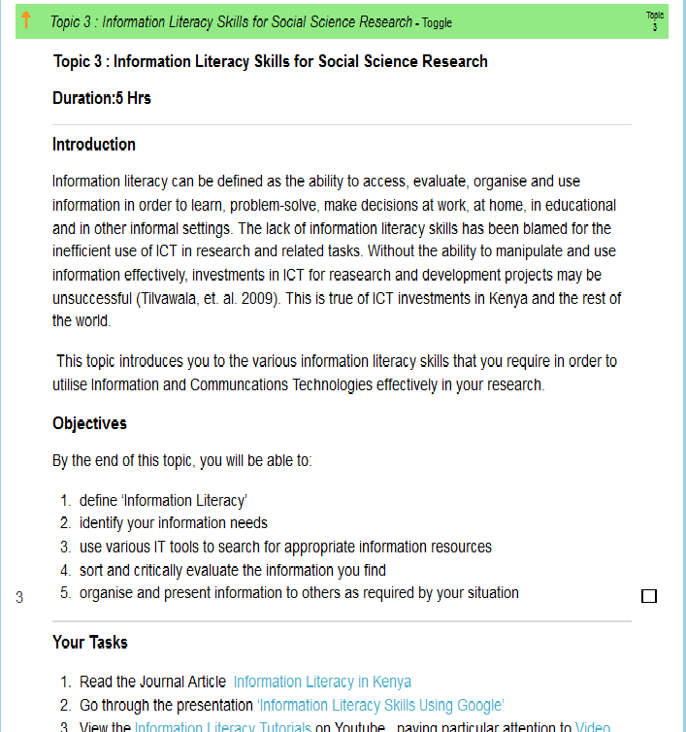

Sample Course Information
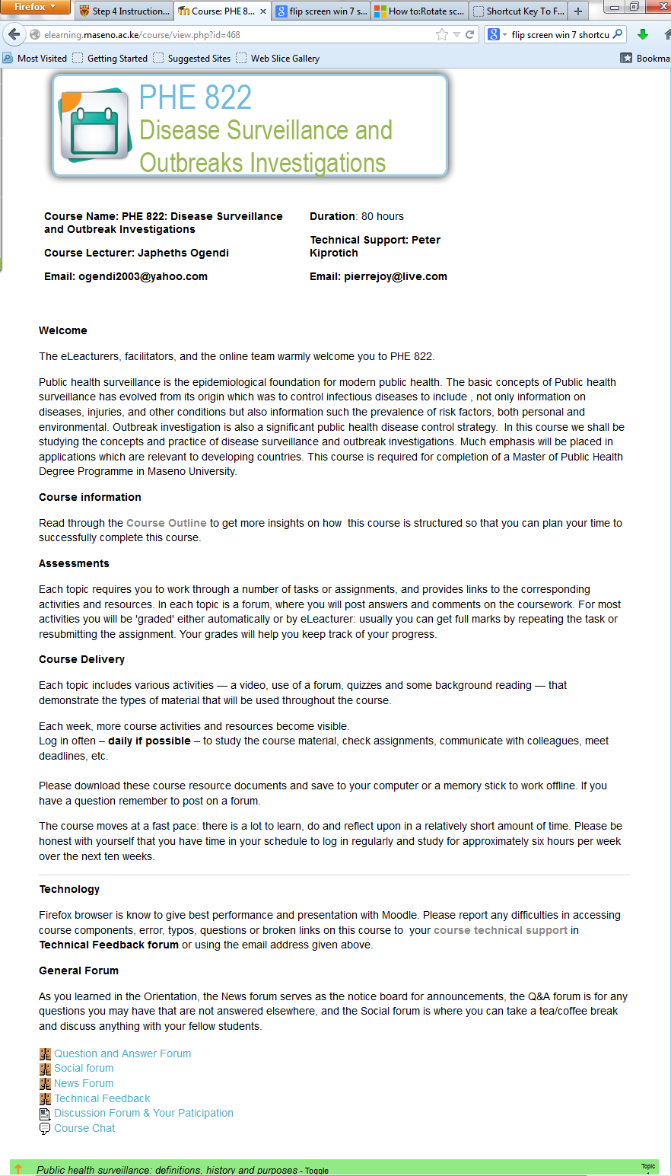
Figure 2 : Sample Course Information extracted from an eCampus module

Index of URIs used in this document

Section | Destination description | URI
Background

