CASE SCENARIO 2
A 35 year old male patient presents to the outpatient clinic with complaints of recurrent crampy periumbilical abdominal pain, episodes of abdominal distension that resolve after 2-3 days of conservative management. These have repeated over the last 6 months. He now reports increase in frequency of the episodes and currently he has had the pain for 4 days with no relief. Instead the pain is now constant, dull and not localised. He has also had two episodes of vomiting
On physical examination you note that his abdomen is soft, non distended with mild tenderness on the left upper quadrant. As part of his work up the following tests are ordered- CBC- normal, UECs- normal urea, creatinine, sodium and potassium levels.
A CT scan abdomen done has the finding shown below
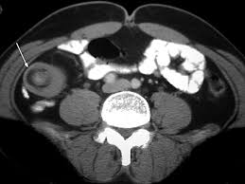

What other findings should be expected during physical examination of the patient?
How else would you evaluate the patient?
What predisposing factors and conditions must you inquire of the patient?
How different is the management of this condition in the various age groups?

